Day4 building dynamic component for your market place – furniture

1. Product listing components
   1. Product on main page (with tags )
      1. Product display with tags



Source code

"use client"

import Link from "next/link";

import { client } from "@/sanity/lib/client";

import { urlFor } from "@/sanity/lib/image";

import { useEffect, useState } from "react";

import React from "react";

import Slider from "react-slick"; // Import react-slick

import "slick-carousel/slick/slick.css"; // Import Slick CSS

import "slick-carousel/slick/slick-theme.css"; // Import Slick Theme

import Image from "next/image";

import P1 from '../public/image 1.png';

import CART from '../../public/website/fluent_cart-24-regular.png';

import Heart from '../../public/website/uil_heart-alt.png';

import magnify from '../../public/website/uil_search-plus (1).png';

function Products() {

const [products, setProduct] = useState<any[]>([]);

useEffect(() => {

async function fetchData() {

const query = `

*[_type == "product" && isFeatured == true] {

_id,

name,

price,

description,

discountPercentage,

stockLevel,

"categoryName": category->title, // Fetch the title of the referenced category

rating,

color[],

additionalInfo,

image

}

`;

const data = await client.fetch(query);

setProduct(data);

}

fetchData();

}, []);

const sliderSettings = {

dots: true, // Pagination dots

infinite: true, // Infinite scrolling

speed: 500, // Transition speed

slidesToShow: 4, // Default slides visible

slidesToScroll: 1,

// Scroll one slide at a time

responsive: [

{

breakpoint: 1024, // lg and below

settings: {

slidesToShow: 1, // Show 1 slide

vertical: true, // Enable vertical scrolling

},

},

],

};

return (

<section className="space-y-4 lg:pr-56 lg:pl-56 pt-20 overflow-x-hidden">

<div className="text-center">

<h1 className="text-3xl font-semibold">Featured Products</h1>

</div>

{/* Slick Carousel */}

<div className="lg:block pt-10">

<Slider {...sliderSettings}>

{products.map((product) => (

<div key={product.id}>

<div className=" bg-white shadow-md rounded-lg transition-shadow duration-300 group relative p-4 mx-auto">

<div className="hidden group-hover:block h-[29px] w-[90px]">

<div className="flex">

<Image src={Heart} alt="c"width={15} height={15}/>

<Image src={CART} alt="c"width={15} height={15}/>

<Image src={magnify} alt="c"width={15} height={15}/>

</div>

</div>

<div className="w-[270px] h-[236px] bg-gray-300 p-4">

{product.image ? (

<Image

src={urlFor(product.image).url()} // Use category.image

alt={product.name || "Category Image"}

width={200}

height={200}

/>

) : (

<p>No image available</p> // Fallback for missing images

)}

<div className="hidden group-hover:block h-[29px] w-[94px] bg-green pl-1 pr-1 text-xs p-2 mt-3 ml-3">

View Details

</div>

</div>

<div className="hover:bg-blue hover:text-white">

<h3 className="text-lg font-semibold mb-2 text-pink text-center">{product.name}</h3>

<p className="text-gray-600 mb-2 text-center">Code:{product.code}</p>

<p className="text-gray-600 mb-2 text-center font-bold">{product.price}</p>

<p className="text-black">{product.category}</p>

</div>

</div>

</div>

))}

</Slider>

{/* Decorative Ellipsis Below */}

</div>

</section>

);

};

export default Products;

1. Product detail page

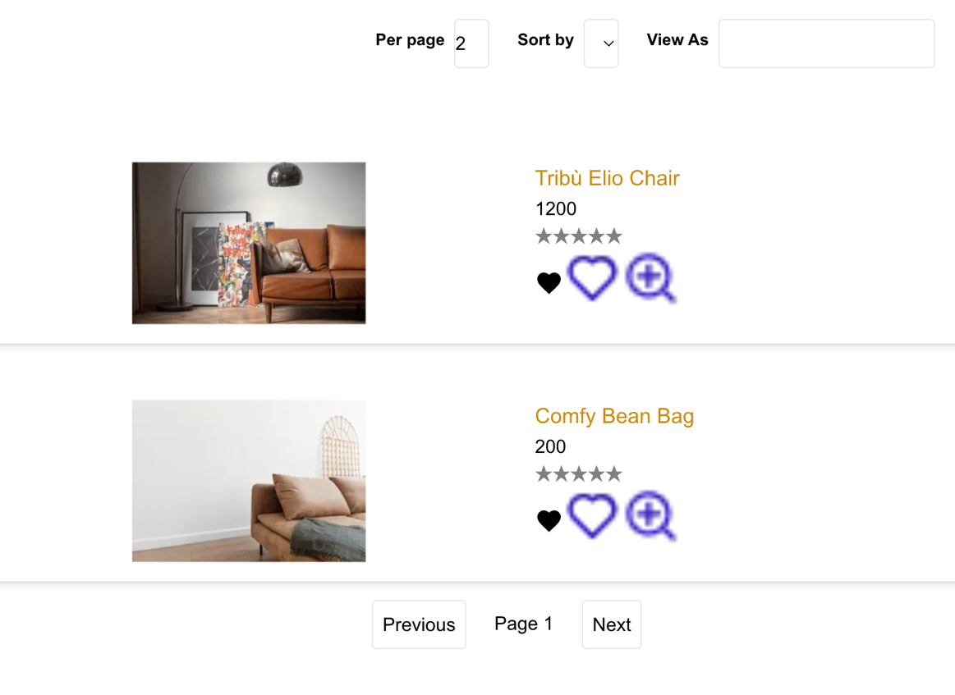

Source code

"use client"

import StarRating from "@/components/StarRating";

import Link from "next/link";

import { urlFor } from "../../../sanity/lib/image";

import { useWishlist } from "../../context/wishContext";

import Image from "next/image";

import Wish from '../../../../public/website/Group 28.png';

import { useEffect, useState } from "react";

import Heart from '../../../../public/website/uil_heart-alt.png';

import Magnify from '../../../../public/website/uil_search-plus.png';

import { client } from "../../../sanity/lib/client"; // Your Sanity client setup

async function getProductsByCategory(id: string, page: number, perPage: number, sortOrder: string) {

const query = `*[_type == "product" && category->_id == $id] | order(price ${sortOrder}) [${(page - 1) * perPage}...${page * perPage}] {

_id,

name,

price,

image,

category-> { _id, name }

}`;

const data = await client.fetch(query, { id });

return data;

}

export default function CategoryPage({ params }: { params: { id: string } }) {

const [products, setProducts] = useState<any[]>([]);

const [loading, setLoading] = useState(true);

const [isOpen, setIsOpen] = useState(false);

const [page, setPage] = useState(1);

const [perPage, setPerPage] = useState(2); // Show 2 products per page

const [sortOrder, setSortOrder] = useState("asc"); // Default sorting: ascending

const { addToWishlist } = useWishlist();

const handlewishlist = (product:any) => {

addToWishlist({ ...product});

};

// Fetch products when the component mounts

useEffect(() => {

async function fetchProducts() {

const data = await getProductsByCategory(params.id, page, perPage, sortOrder);

setProducts(data);

setLoading(false);

}

fetchProducts();

}, [params.id, page, perPage, sortOrder]); // Dependency array to fetch again if the category changes

if (loading) return <div>Loading...</div>;

return (

<div className="">

<div className="mx-auto w-full bg-lightpurple">

<div className="grid grid-cols-1 md:grid-cols-2 lg:grid-cols-3 gap-4 p-10">

<nav className="text-sm">

<h1 className="text-6xl text-black">Shop</h1>

<ol className="flex space-x-2">

<li>

<Link href="/" className="text-blue-500 hover:text-blue-700">Home</Link>

</li>

<li className="text-gray-500">.</li>

<li>

<Link href="#" className="text-blue-500 hover:text-blue-700">Shop</Link>

</li>

</ol>

</nav>

</div>

</div>

<div className="grid grid-cols-1 lg:grid-cols-2 xl:grid-cols-2 2xl:grid-cols-2 gap-4">

<div className=" p-4"><h1 className="text-black font-extrabold">Ecommerce accessories & Fashion Items</h1></div>

<div className="p-4">

<div className="flex gap-4">

<div className="flex">

<label htmlFor="item1" className="text-sm font-semibold p-2">Per page</label>

<input type="number" id="item1" className="border rounded w-[30px]" value={perPage} onChange={(e) => setPerPage(Number(e.target.value))} />

</div>

<div className="flex">

<label htmlFor="item2" className="text-sm font-semibold p-2">Sort by</label>

<select id="item2" className="border p-2 rounded w-[30px]" onChange={(e) => setSortOrder(e.target.value)}>

<option value="asc">Price: Low to High</option>

<option value="desc">Price: High to Low</option>

</select>

</div>

<div className="flex">

<label htmlFor="item3" className="text-sm font-semibold p-2">View As</label>

<input type="text" id="item3" className="border p-2 rounded" />

</div>

</div>

</div>

</div>

<div className="h-screen grid grid-cols-1 lg:grid-cols-5">

{/* Left Sidebar (20%) */}

<div

className={`lg:block ${isOpen ? "block" : "hidden"} lg:col-span-1 text-black p-4 transition-all duration-300 ease-in-out`}

>

<button onClick={() => setIsOpen(false)} className="lg:hidden text-white">

Close

</button>

<div className="space-y-4">

<div>

<h1 className="text-sm">Product Brand</h1>

<div className="flex items-center space-x-2">

<input type="checkbox" id="checkbox1" className="form-checkbox text-blue-500" />

<label htmlFor="checkbox1" className="text-lg font-semibold">Unique Furnitture Restor</label>

</div>

<div className="flex items-center space-x-2">

<input type="checkbox" id="checkbox1" className="form-checkbox text-blue-500" />

<label htmlFor="checkbox1" className="text-lg font-semibold">Unique Furnitture Restor</label>

</div>

<div className="flex items-center space-x-2">

<input type="checkbox" id="checkbox1" className="form-checkbox text-blue-500" />

<label htmlFor="checkbox1" className="text-lg font-semibold">Fusion Dot High Fashion</label>

</div>

</div>

<br/>

<div>

<h1 className="text-sm">Discount Offer</h1>

<div className="flex items-center space-x-2">

<input type="checkbox" id="checkbox1" className="form-checkbox text-blue-500" />

<label htmlFor="checkbox1" className="text-lg font-semibold">20% cash back</label>

</div>

<div className="flex items-center space-x-2">

<input type="checkbox" id="checkbox1" className="form-checkbox text-blue-500" />

<label htmlFor="checkbox1" className="text-lg font-semibold">5% cash back offer</label>

</div>

<div className="flex items-center space-x-2">

<input type="checkbox" id="checkbox1" className="form-checkbox text-blue-500" />

<label htmlFor="checkbox1" className="text-lg font-semibold">25% discount offer</label>

</div>

</div>

<div>

<h1 className="text-sm">Rating Item</h1>

<div className="flex items-center space-x-2">

<input type="checkbox" id="checkbox1" className="form-checkbox text-blue-500" />

<StarRating rating={4}/>

</div>

<div className="flex items-center space-x-2">

<input type="checkbox" id="checkbox1" className="form-checkbox text-blue-500" />

<StarRating rating={4}/>

</div>

<div className="flex items-center space-x-2">

<input type="checkbox" id="checkbox1" className="form-checkbox text-blue-500" />

<StarRating rating={4}/>

</div>

<br/>

<div>

<h1 className="text-sm">Categories</h1>

<div className="flex items-center space-x-2">

<input type="checkbox" id="checkbox1" className="form-checkbox text-blue-500" />

<label htmlFor="checkbox1" className="text-lg font-semibold">Electronic</label>

</div>

<div className="flex items-center space-x-2">

<input type="checkbox" id="checkbox1" className="form-checkbox text-blue-500" />

<label htmlFor="checkbox1" className="text-lg font-semibold">Jewllery</label>

</div>

</div>

<br/>

<div>

<h1 className="text-sm">Price Filter</h1>

<div className="flex items-center space-x-2">

<input type="checkbox" id="checkbox1" className="form-checkbox text-blue-500" />

<label htmlFor="checkbox1" className="text-lg font-semibold">$0-$500</label>

</div>

<div className="flex items-center space-x-2">

<input type="checkbox" id="checkbox1" className="form-checkbox text-blue-500" />

<label htmlFor="checkbox1" className="text-lg font-semibold">$90-900</label>

</div>

</div>

</div>

</div>

</div>

{/* Right Content (80%) */}

<div className="lg:col-span-4 p-4">

{/* Toggle Icon for Mobile */}

<button

onClick={() => setIsOpen(true)}

className="lg:hidden text-xl text-gray-800"

>

&#9776; {/* Hamburger icon */}

</button>

<div className="mt-4">

<div>

{products.map((p:any) => (

<div className="grid grid-cols-1 lg:grid-cols-2 xl:grid-cols-2 2xl:grid-cols-2 gap-4 mt-8 text-black lg:pr-56 lg:pl-56 shadow-md bg-white"key={p.id}>

<div className="p-4"> {p.image ? (

<Image

src={urlFor(p.image).url()} // Use category.image

alt={p.name || "Category Image"}

width={200}

height={200}

/>

) : (

<p>No image available</p>

)}</div>

<div className="p-4"><h1 className="text-lg"><Link

href={`/product/${p._id}`}

className="text-yellow-600"

>{p.name}</Link></h1>

<div className="text-black"><p>{p.price}<span className="hover:text-pink text-black">{p.discount}</span></p><StarRating rating={p.rating}/>

<p>{p.description}</p>

</div>

<div className="flex">

<button

className=" text-white mt-2"

onClick={handlewishlist}

>

<svg xmlns="http://www.w3.org/2000/svg" viewBox="0 0 24 24" fill="#000000" width="24" height="24">

<path d="M12 21.35l-1.45-1.32C5.4 15.36 2 12.28 2 8.5 2 5.42 4.42 3 7.5 3c1.74 0 3.41.81 4.5 2.09C13.09 3.81 14.76 3 16.5 3 19.58 3 22 5.42 22 8.5c0 3.78-3.4 6.86-8.55 11.54L12 21.35z"/>

</svg>

</button>

<Image src={Heart} alt="c" height={50} width={50}/>

<Image src={Magnify} alt="c" height={50} width={50}/>

</div>

</div>

</div>

))}

</div>

<div className="mt-4 flex justify-center space-x-4">

<button

onClick={() => setPage(prev => Math.max(prev - 1, 1))}

className="border p-2 rounded"

>

Previous

</button>

<span className="p-2">Page {page}</span>

<button

onClick={() => setPage(prev => prev + 1)}

className="border p-2 rounded"

>

Next

</button>

</div>

</div>

</div>

</div>

</div>

);

}

Related product

"use client"

import Link from "next/link";

import { client } from "@/sanity/lib/client";

import { urlFor } from "@/sanity/lib/image";

import { useEffect, useState } from "react";

import React from "react";

import Slider from "react-slick"; // Import react-slick

import "slick-carousel/slick/slick.css"; // Import Slick CSS

import "slick-carousel/slick/slick-theme.css"; // Import Slick Theme

import Image from "next/image";

import CART from '../../public/website/fluent_cart-24-regular.png';

import Heart from '../../public/website/uil_heart-alt.png';

import magnify from '../../public/website/uil_search-plus (1).png';

interface ProductsProps {

category: string; // New prop to pass category name

}

function Products({ category }: ProductsProps) {

const [products, setProduct] = useState<any[]>([]);

useEffect(() => {

async function fetchData() {

// Adjust the query to use category's name to fetch matching products

const query = `

*[_type == "product" && category -> _id == $category] {

_id,

name,

price,

description,

discountPercentage,

stockLevel, // Fetch category title directly

rating,

color[],

additionalInfo,

image

}

`;

// Pass the category name as a parameter for querying

const data = await client.fetch(query, { category });

setProduct(data);

}

fetchData();

}, [category]); // Dependency on category prop to refetch when it changes

const sliderSettings = {

dots: true, // Pagination dots

infinite: true, // Infinite scrolling

speed: 500, // Transition speed

slidesToShow: 4, // Default slides visible

slidesToScroll: 1, // Scroll one slide at a time

responsive: [

{

breakpoint: 1024, // lg and below

settings: {

slidesToShow: 1, // Show 1 slide

vertical: true, // Enable vertical scrolling

},

},

],

};

return (

<section className="space-y-4 lg:pr-56 lg:pl-56 pt-20 overflow-x-hidden">

<div className="text-center">

<h1 className="text-3xl font-semibold">Related Products </h1>

</div>

{/* Slick Carousel */}

<div className="lg:block pt-10">

<Slider {...sliderSettings}>

{products.map((product) => (

<div key={product._id}>

<div className="bg-white shadow-md rounded-lg transition-shadow duration-300 group relative p-4 mx-auto">

<div className="hidden group-hover:block h-[29px] w-[90px]">

<div className="flex">

<Image src={Heart} alt="c" width={15} height={15} />

<Image src={CART} alt="c" width={15} height={15} />

<Image src={magnify} alt="c" width={15} height={15} />

</div>

</div>

<div className="w-[270px] h-[236px] bg-gray-300 p-4">

{product.image ? (

<Image

src={urlFor(product.image).url()}

alt={product.name || "Product Image"}

width={200}

height={200}

/>

) : (

<p>No image available</p> // Fallback for missing images

)}

<div className="hidden group-hover:block h-[29px] w-[94px] bg-green pl-1 pr-1 text-xs p-2 mt-3 ml-3">

View Details

</div>

</div>

<div className="hover:bg-blue hover:text-white">

<h3 className="text-lg font-semibold mb-2 text-pink text-center">{product.name}</h3>

<p className="text-gray-600 mb-2 text-center">Code: {product.code}</p>

<p className="text-gray-600 mb-2 text-center font-bold">{product.price}</p>

{/* Render category name here */}

<p className="text-black">{product.category}</p>

</div>

</div>

</div>

))}

</Slider>

</div>

</section>

);

};

export default Products;

1. Advanced category filtering

Source code

"use client"

import Link from "next/link";

import React from "react";

import { client } from "@/sanity/lib/client";

import { urlFor } from "@/sanity/lib/image";

import { useState ,useEffect } from "react";

import Slider from "react-slick"; // Import react-slick

import "slick-carousel/slick/slick.css"; // Import Slick CSS

import "slick-carousel/slick/slick-theme.css"; // Import Slick Theme

import Image from "next/image";

function Products() {

const [products1, setProduct] = useState<any[]>([]);

useEffect(() => {

async function fetchData() {

const query = `

*[_type == "category1"] {

_id,

id,

name,

image

}

`;

const data = await client.fetch(query);

setProduct(data);

}

fetchData();

}, []);

const sliderSettings = {

dots: true, // Pagination dots

infinite: true, // Infinite scrolling

speed: 500, // Transition speed

slidesToShow: 4, // Default slides visible

slidesToScroll: 1,

// Scroll one slide at a time

responsive: [

{

breakpoint:1366,

settings:{

slideToshow:2,

vertical:false

}

},

{

breakpoint: 1024, // lg and below

settings: {

slidesToShow: 2, // Show 1 slide

vertical: false, // Enable vertical scrolling

},

},

{

breakpoint: 768, // lg and below

settings: {

slidesToShow: 1, // Show 1 slide

vertical: true, // Enable vertical scrolling

},

},

{

breakpoint: 640, // md and below

settings: {

slidesToShow: 1, // Show 2 slides

vertical: false, // Horizontal scrolling

},

},

],

};

return (

<section className="space-y-4 lg:pr-32 lg:pl-32 pt-20 sm:pr-20 sm:pl-20 overflow-x-hidden">

<div className="text-center">

<h1 className="text-3xl font-semibold">Top Categories</h1>

</div>

<div className="lg:block pt-10 slider-container mx-auto p-2 sm:pl-10">

<Slider {...sliderSettings}>

{products1.length === 0 ? (

<p>No categories available</p> // Fallback if no categories found

) : (

products1.map((c) => (

<div key={c._id} className="flex justify-center" data-testid="product-category">

<div className="w-[269px] h-[345px] bg-white group relative mx-auto">

{c.image ? (

<Image

src={urlFor(c.image).url()} // Use category.image

alt={c.name || "Category Image"}

width={200}

height={200}

/>

) : (

<p>No image available</p>

)}

<div className="h-auto text-center">

<h3 className="hover:text-pink text-gray-800">{c.name}</h3>

<Link href={`category/${c._id}`}>

<p className="underline decoration-2 decoration-blue">

Read More

</p>

</Link>

</div>

</div>

</div>

))

)}

</Slider>

</div>

</section>

);

}

export default Products;

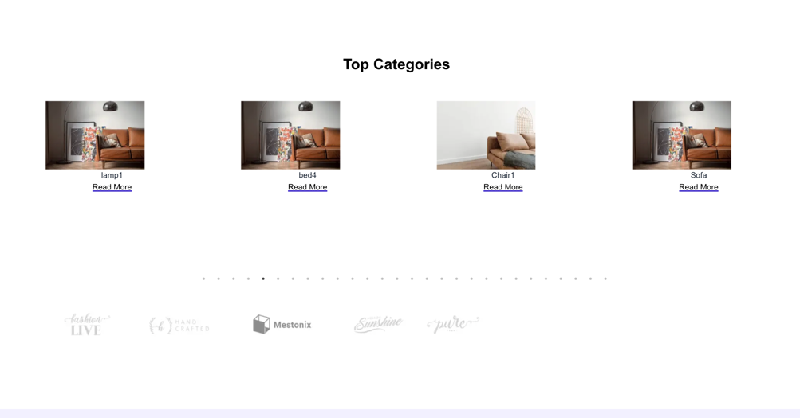

1. Pagination and related product page

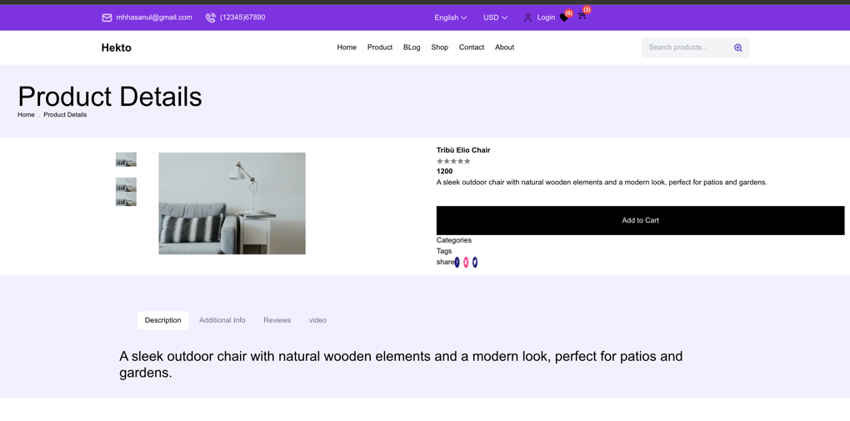

* 1. 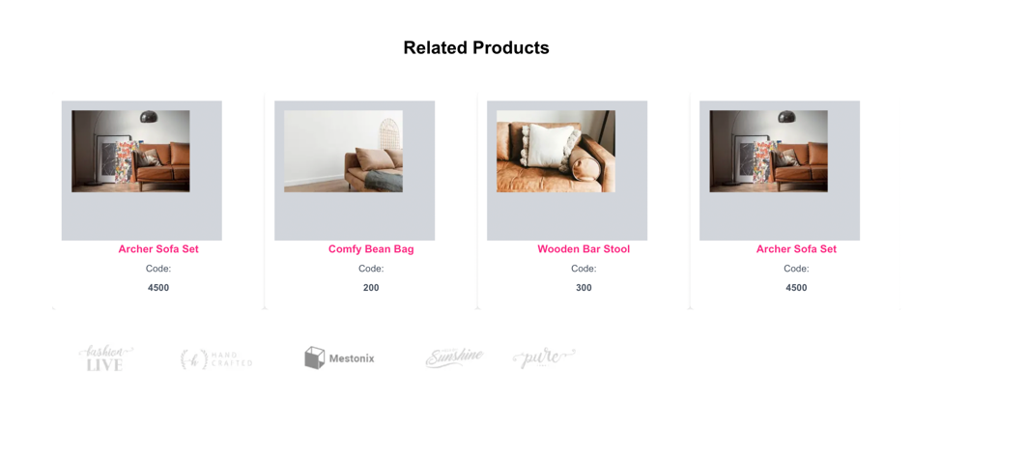

1. Components responsive
   1. Yes it is responsive it just few amendments
   2. 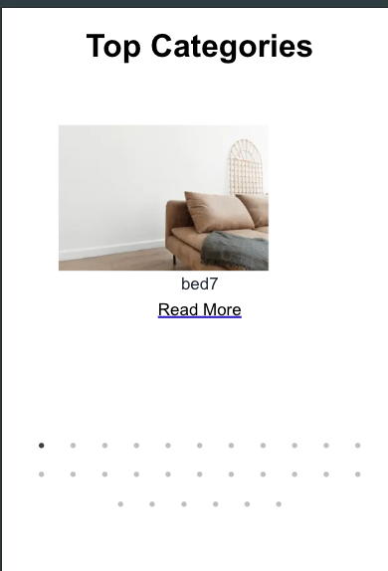
2. Features included :
3. Product listing --- on main page
4. Category when clicking on category it directs to product detail page using dynamic routing based on category->[id] and it produces url like http:{baseurl}/category/catefory_id[dynamic]
5. When clicking on category href in list product listing page it produces url like http{baseurl}/product/productid
6. When going to product detail page we have add to cart and wish list option the supported using context api the cart price is display on top
7. Search filter when clicking on search button and putting value “chair” it filter in model
8. Source code
   1. <https://github.com/maeyda-masroor/my-appv1/tree/main>